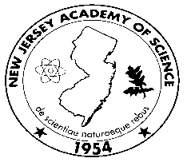61th Annual Meeting of the New Jersey Academy of Science
Saturday April30th, 2016
Kean University New Jersey Center for Science Technology and Mathematic

8:30 am & on Check-In (No on-site registration)

9:00 – 9:20 am Welcoming Remarks

9:30 – 12:00 am Junior Academy Oral Presentations

***Posters for Presentation by Senior Academy are to be on display by 12:00pm

12:00 – 1:15 pm Lunch (Box Lunches and drinks will be made available to those who ordered when registering for the meeting.)

Judges Conference (512 is available for judges)

Posters on Display
Posters must be able to stand alone on top of a table.

1:15 pm – 2:30 pm Senior Academy Poster Session
(Student Posters judged thru 3:30pm)

2:30- 3:30 Keynote Address: Zika Virus

Shereen Semple, New Jersey Department of Public Health
Infectious and Zoonotic Disease Program

3:30 – 3:45 pm Junior Academy (High School) Awards Ceremony )
2015/16 Grant-In-Aid Junior Academy Winners Acknowledged
1st, 2nd & 3rd Place Winners for Junior Academy Student
Oral Presentations

3:45 – 4:00 pm Senior Academy Awards Ceremony
Outstanding Senior Academy Student Poster Presentations (Undergrad vs. Graduate)

