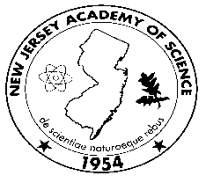63th Annual Meeting of the New Jersey Academy of Science
Saturday May 18th, 2019
Kean University New Jersey Center for Science Technology and Mathematics

8:30 am & on Check-In (No on-site registration) 2nd Floor Lobby
(by driveway)

9:00 – 9:20 am Welcoming Remarks Auditorium (by registration tables)

9:30 – 12:00 am Junior Academy Oral Presentations Classrooms

***Posters for Presentation by Senior Academy are to be on display by 12:00pm

12:00 – 1:15 pm Lunch (Box Lunches and drinks will be made available to those who ordered when registering for the meeting.)
Lunch on 6th floor

Posters on Display
Posters must be able to stand alone on top of a table.

1:15 pm – 2:00 pm Senior Academy Poster Session 6th Floor
(Student Posters judged thru 3:30pm)

2:00- 3:00 Keynote Address: Forest Ecology Auditorium

Daniela Shebitz,
School of Environmental and Sustainability Sciences, Kean University

3:00 – 3:30 pm Junior Academy Awards Ceremony Auditorium

2015/16 Grant-In-Aid Junior Academy Winners Acknowledged
1st, 2nd & 3rd Place Winners for Junior Academy Student
Oral Presentations

3:30 – 4:00 pm Senior Academy Awards Ceremony Auditorium

4:00 Academy Members Business Meeting (TBA)

