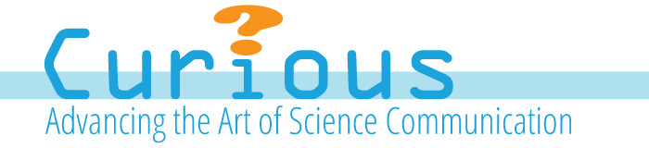

CALL FOR CURIOUS, CREATIVE HIGH SCHOOL SCIENCE WRITERS

Between March 1 and April 1, 2014, curiousYOUNGwriters (cYw) is accepting applications from new student authors/storytellers. Encourage your student to apply for this unique online publishing opportunity.

curiousYOUNGwriters (cYw) is an innovative high school science collaborative that is located at the intersection of science, technology, engineering, mathematics and ART (steAm). Read all about it: www.curiousyoungwriters.org

Working with multi-functional creative transfer teams, students research, write and publish compelling digital stories featuring unusual animal models that are helping to solve some enduring medical mysteries.

Hosted by States United for Biomedical Research (SUBR) and endorsed by The Biology Teachers Association of New Jersey (BTANJ), the cYw Faculty Advisory Board is comprised of biology and language arts teachers who share a passion for research and teaching.

cYw will hold its first high school science writer’s forum and training for selected applicants on May 17 at Monmouth University. Participation is mandatory.

Benefits of being a cYw author:
- Publication in a credible moderated digital platform
- An enhanced portfolio
- Strengthened critical thinking inquiry-based skills
- Marketable science communication skills
- Stipend and Certificate upon posting of story
- Association with an online community of trusted science communicators

Find the student author application at:
http://www.curiousyoungwriters.org/for-writers/

- APPLICATION PERIOD: March 1-April 1, 2014

Please download and share this flyer with colleagues and students.
Questions should be directed to the cYw Program Coordinator at: questionsforcuriouswriters@gmail.com

